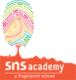
English Revision worksheet
Grade II
I.Rearrange the words-

1.Pigeon /the /tree/ is/on/the.

_________________________________________________________
2.Out side /is/ it /sunny.
___________________________________________________________________________________________________
3.eat /to/ like /I/ banana.
____________________________________________________________________________________________________
4.Where /apple/is/the.
____________________________________________________________________________________________________
II. Describe the picture.
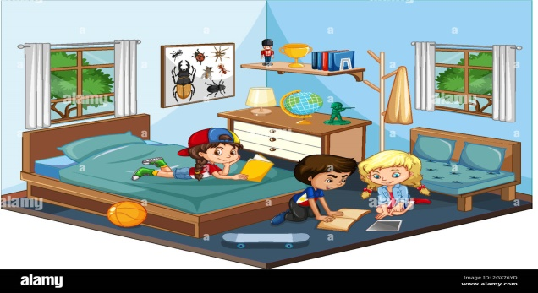_
____________________________________________________________________________________________________________________________________________________________________________________________________________________________________________________________________________________________________________IV. Write about your favourite food-
__________________________________________________________________________________________________________________________________________________________________________________________________________________________________________________________V.Write the meanings for-
- Panic-
- Sprinkle-
- Wholesome-
- Labour-
- Wrapped-

